**Housing Community and Economic Development**

Housing generally refers to the social problem of ensuring that members of society have a home in which to live, whether this is a house, or some other kind of dwelling, lodging, or shelter.

The term informal housing can include any form of shelter or settlement (or lack thereof) which is illegal, falls outside of government control or regulation, or is not afforded protection by the state. As such, the informal housing industry is part of the informal sector. To have informal housing status is to exist in ‘a state of deregulation, one where the ownership, use, and purpose of land cannot be fixed and mapped according to any prescribed set of regulations or the law.’ While there is no global unified law of property ownership typically, the informal occupant or community will lack security of tenure and, with this, ready or reliable access to civic amenities (potable water, electricity and gas supply, sanitation and waste collection). Due to the informal nature of occupancy, the state will typically be unable to extract rent or land taxes.

The term informal housing is useful in capturing informal populations other than those living slum settlements or shanty towns, which are defined more narrowly by the UN Habitat as ‘contiguous settlement where the inhabitants are characterizes as having inadequate housing and basic services...often not recognized or addressed by the public authorities an integral or equal part of the city.'

Common categories or terms for informal housing include slums, slum settlements, shanty towns, squats, homelessness and pavement.

The unifying goal of CEDH is to improve the lives of low-income and marginalized groups directly, using a variety of tools and strategies ranging from organizing and activism, housing development and housing policy reform, job creation, skill development, and traditional and innovative financial instruments.

Healthy cities and regions need affordable housing; safe, vibrant and diverse neighborhoods; and good jobs and public services. The tasks are complex and challenging: reconciling affluence and equity; mobility and a sense of place; global markets and local traditions; retaining manufacturing jobs while embracing post-industrial digital technologies; providing housing as both a market commodity and a social need. Moreover, these various tasks work best if interconnected: housing integrated into the larger neighborhood; economic activity embedded into local communities; and equal partnerships between public and private actors.

The Housing, Community, and Economic Development (HCED) concentration takes on these challenges through planning for housing, neighborhoods, and the economic well-being of a community and the larger region. The goals are to increase social and economic capital and improve the quality of life generally but particularly in low-income, minority and other disadvantaged communities.

Planners with this background work with local residents, neighborhood and community organizations, community development corporations, and nonprofit and for-profit housing developers, as well as for municipal, regional, state, and federal agencies and the private sector. Their work is directed toward securing decent, affordable housing; improving job opportunities; increasing safety; and restoring or maintaining community stability. They work for state departments of commerce or economic development, city departments and mayors' offices, and federal agencies to plan and implement development projects, strengthen tax base, improve employment opportunities, and enhance housing policy.

HCED is a broad concentration consisting of three tracks: housing; community development; and urban and regional economic development. HCED students may choose to specialize in one or more of these interrelated but distinctive tracks and do not need to take courses across all three areas. Students acquire knowledge of political, economic, and social systems that lead to urban growth and decline, low incomes, inadequate housing, unemployment, uneven development, deindustrialization, and poor neighborhoods. Students may further specialize in particular skills and techniques, such as: local and regional economic analysis; real estate finance and development; neighborhood planning; site planning; nonprofit management; public-private partnerships; and community participation (to facilitate an open planning process with people and organizations of multiple backgrounds and interests).

Housing and economic development law concerns policy, advocacy, and litigation regarding affordable housing, poverty, and community economic development. Lawyers in housing and economic development may serve clients dealing with unfair housing issues by helping them through the litigation or negotiation process, or be involved in responsible financial service-related policy work. These fields are closely intertwined, and frequently work together in advocacy campaign coalitions. Lawyers in housing and economic development often work in non-profit organizations or with federal, state and local government agencies.

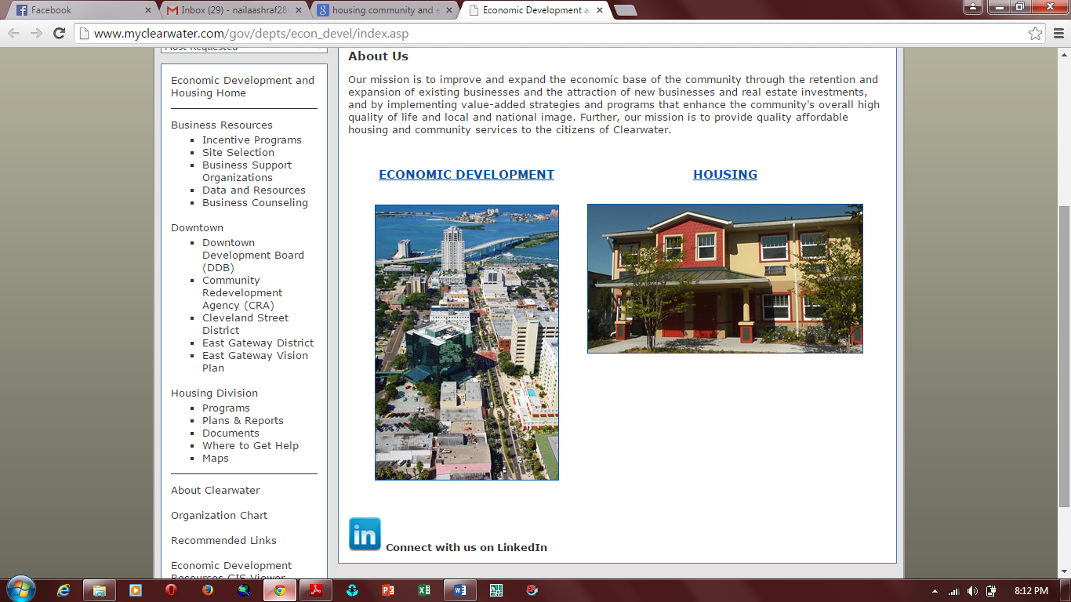

<https://www.law.georgetown.edu/careers/career-planning/practice-areas/housing-community-economic-development.cfm>

<http://www.cacities.org/Policy-Advocacy/Policy-Development/Housing,-Community-and-Economic-Development-Policy>